# **Name: Abdurrahman Qureshi**

# **Roll No: 242466**

Practical No: 11

Date Of Performance: 16/09/2025

Aim: Deploying a NGINX Server in a Docker Container and Modifying the index.html from Within the Running Container.

[Install docker on AWS EC2 –Ubuntu by using curl

#curl -fsSL https://get.docker.com -o get-docker.sh

#sh get-docker.sh ]

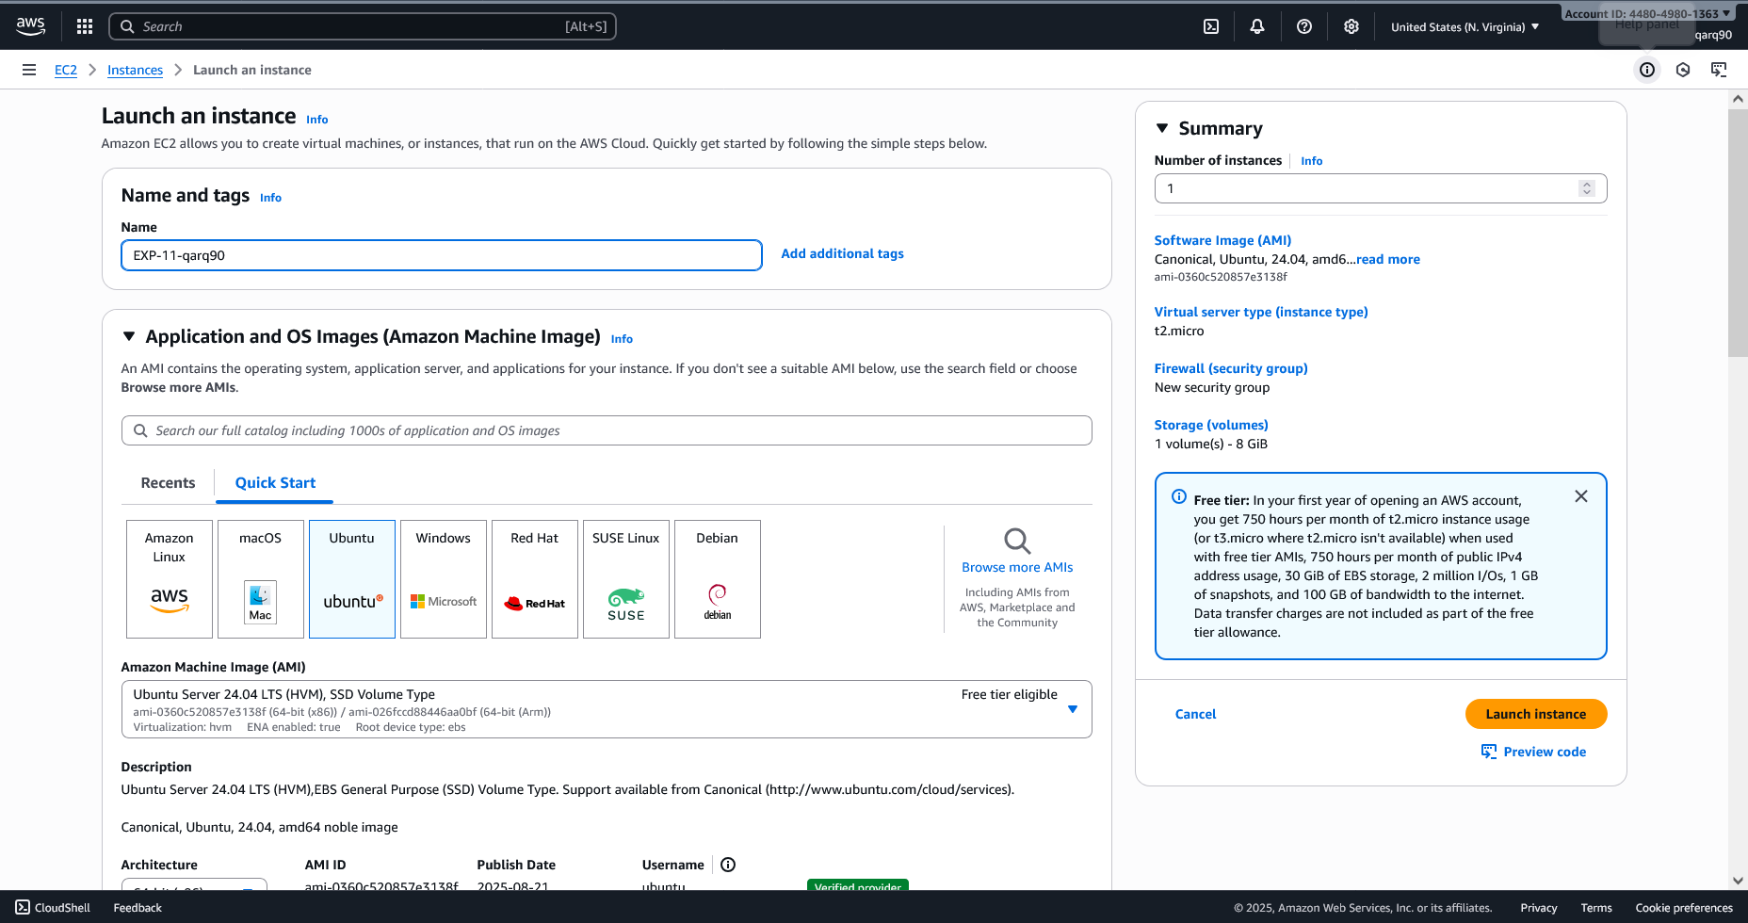

Setting up the EC2 Instance

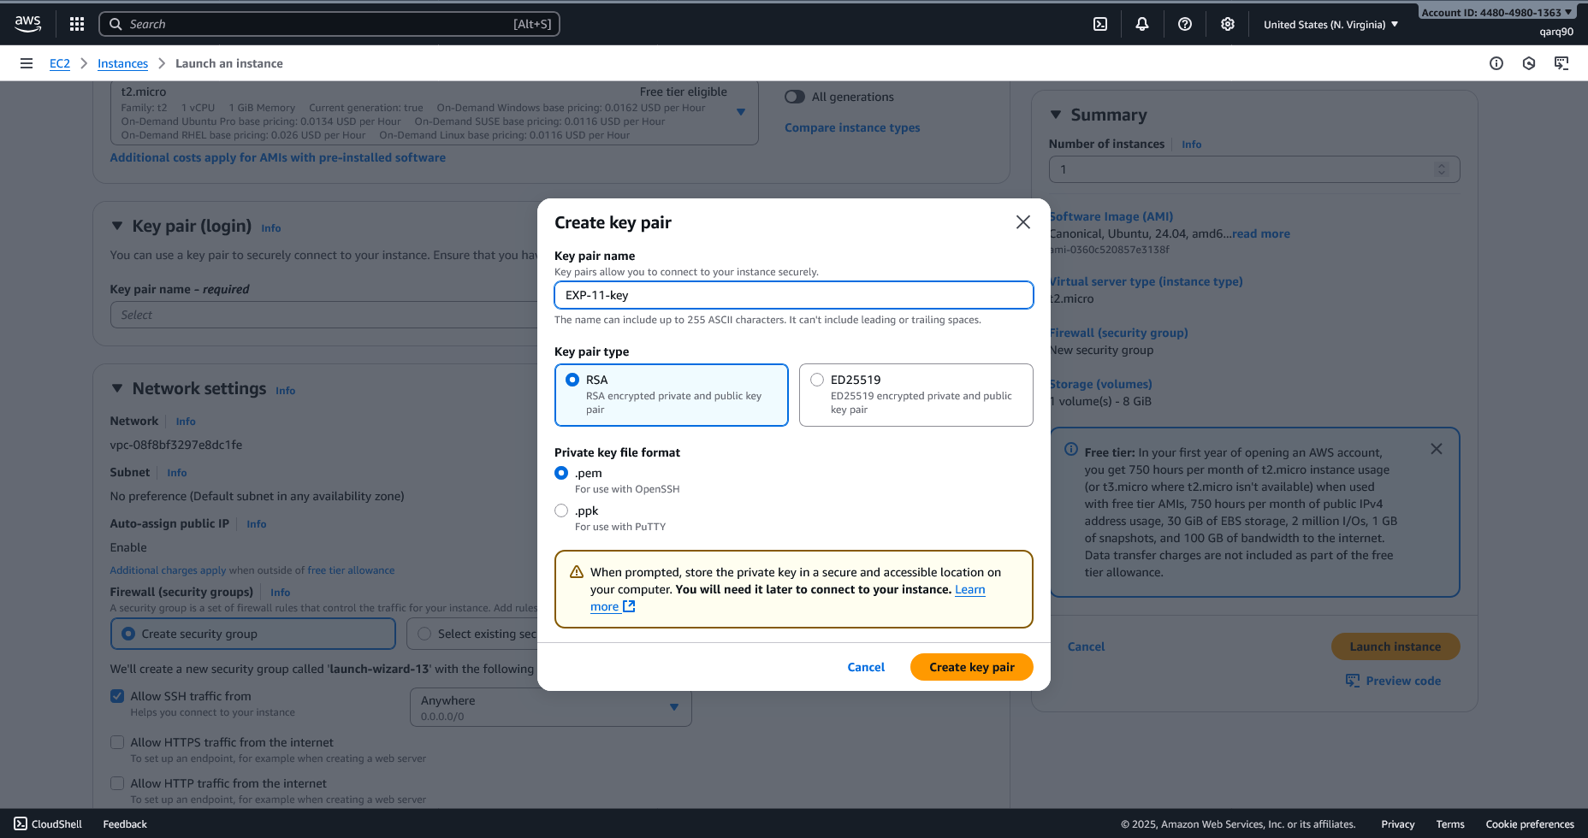

Creating Key Pair

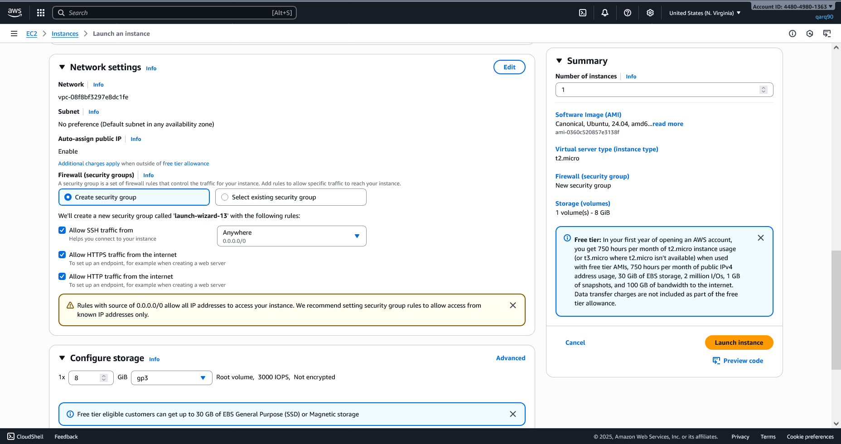

Configuring Network Settings of the Instance

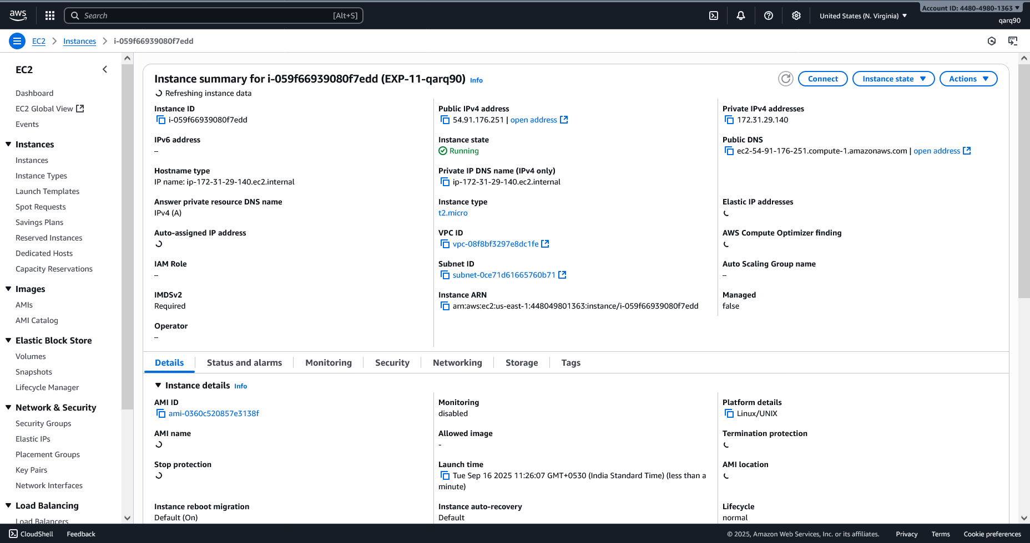

Instance Details

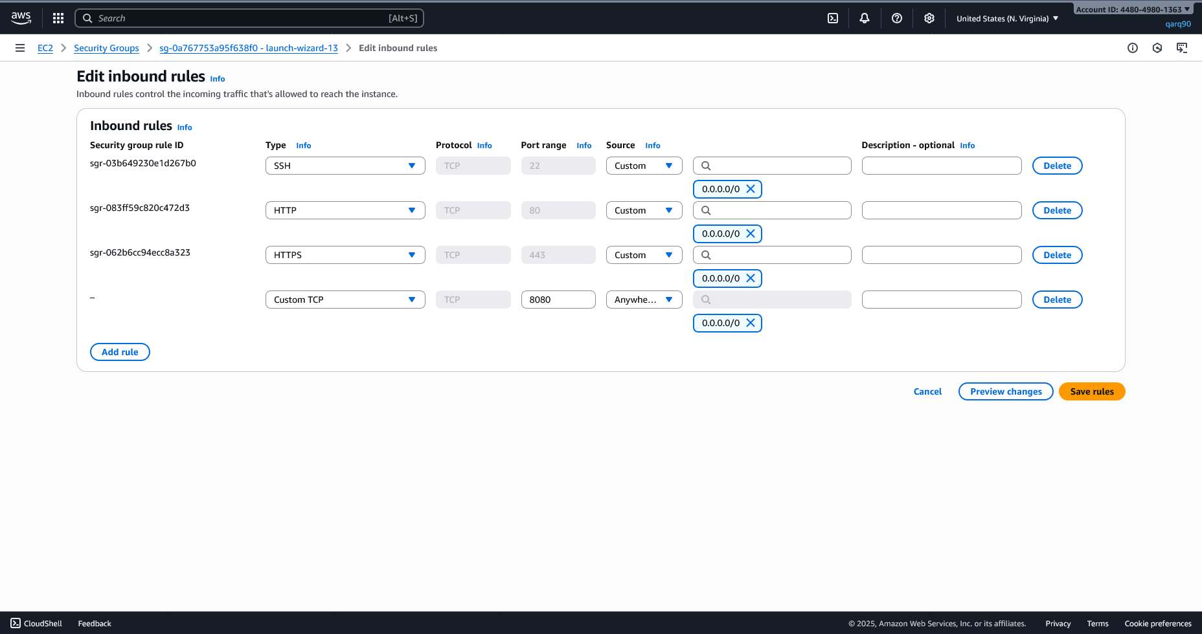

Editing the inbound rules

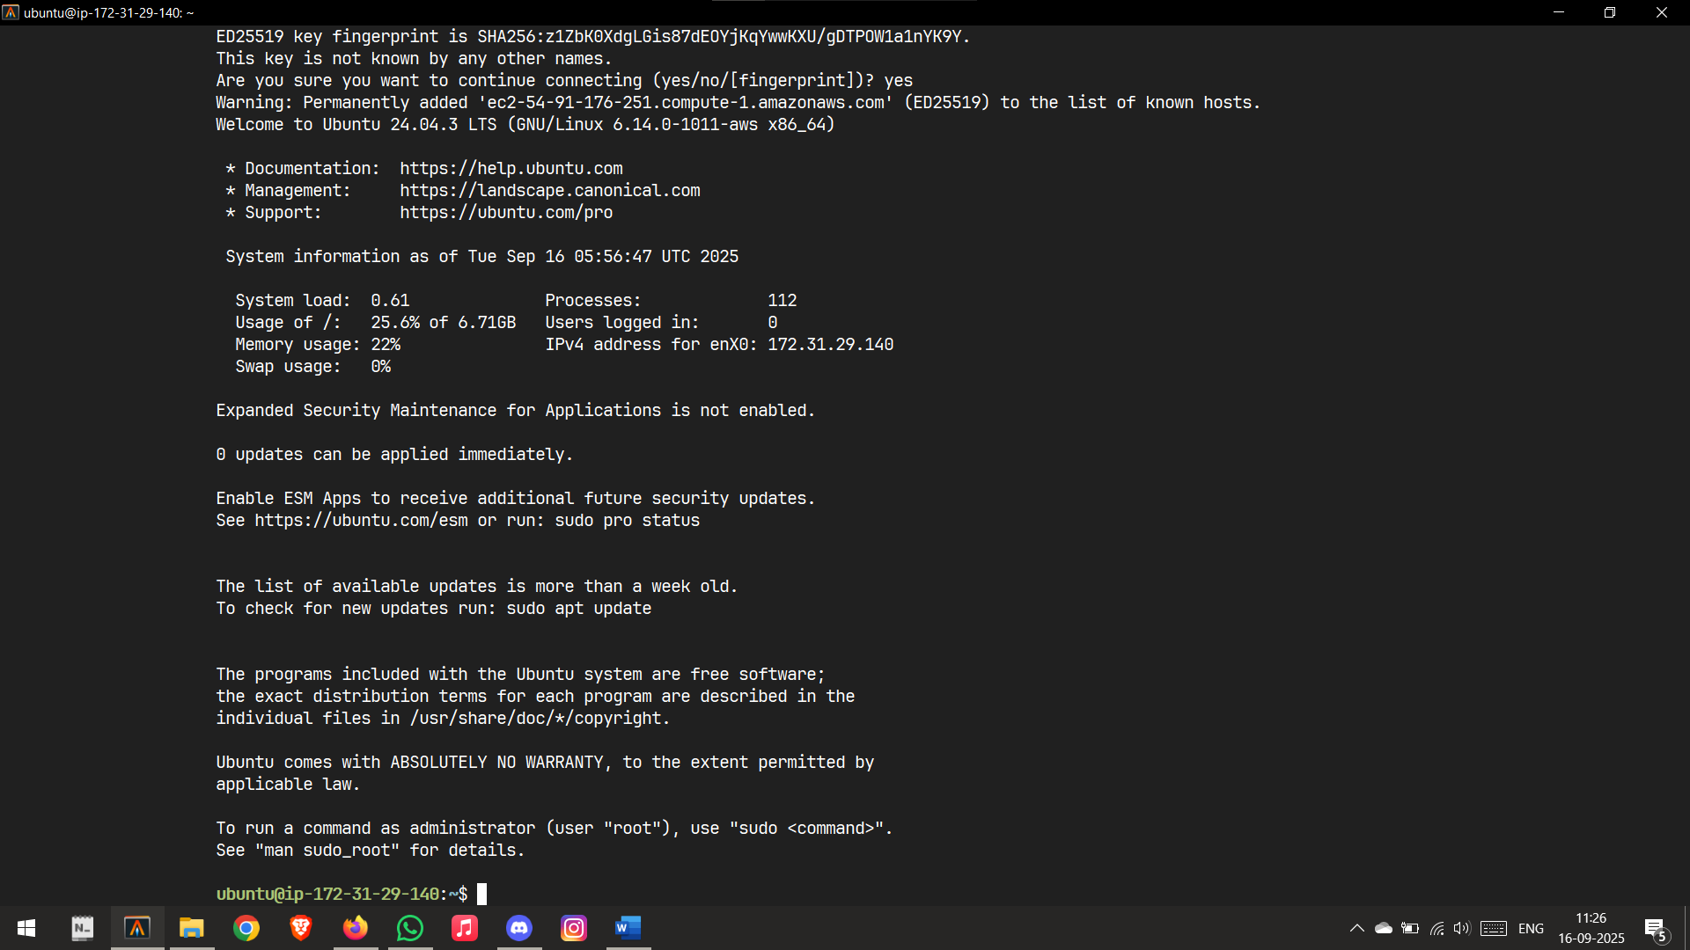

Connected to Instance

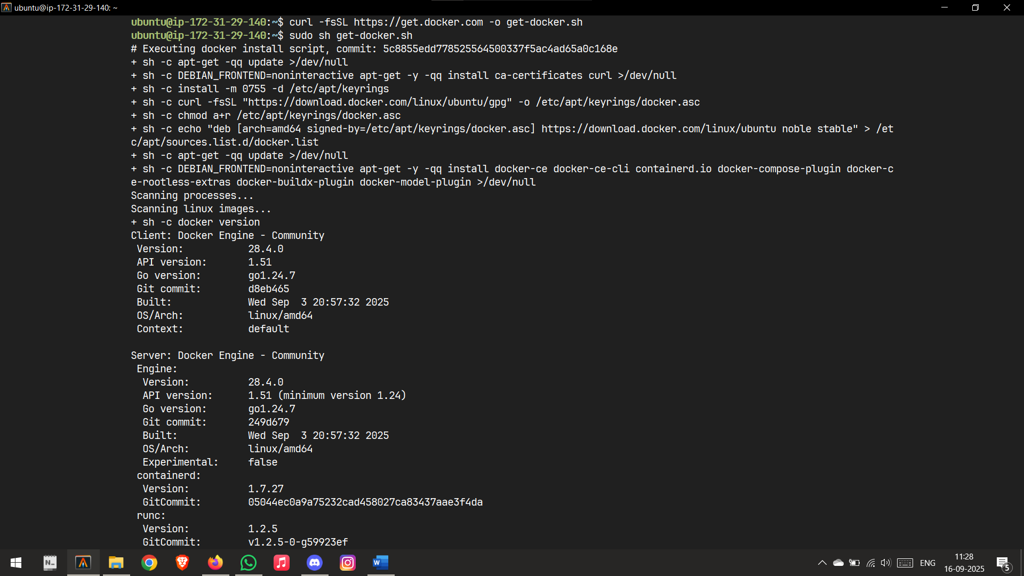

Installing Docker

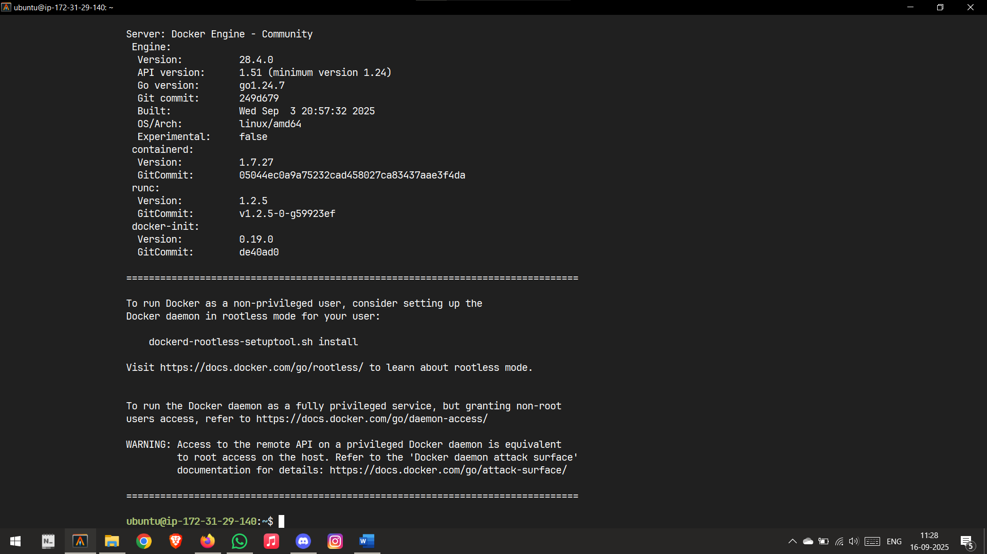

Configuring Docker

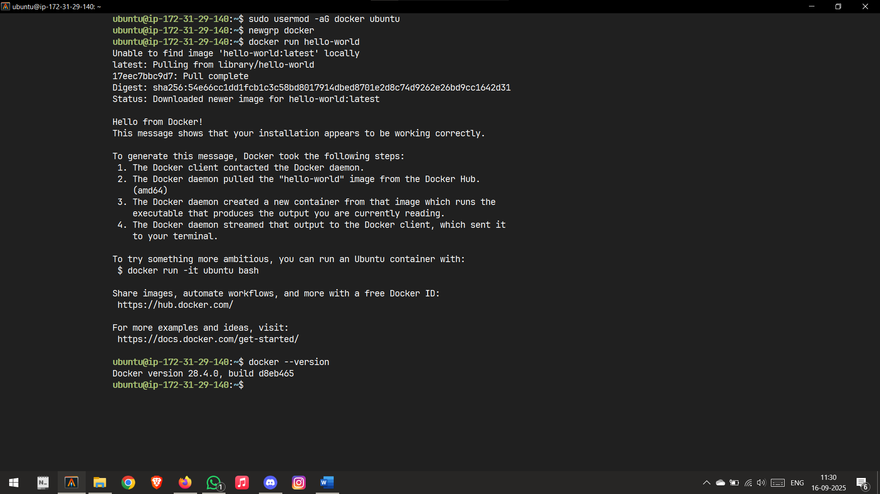

Configuration Complete

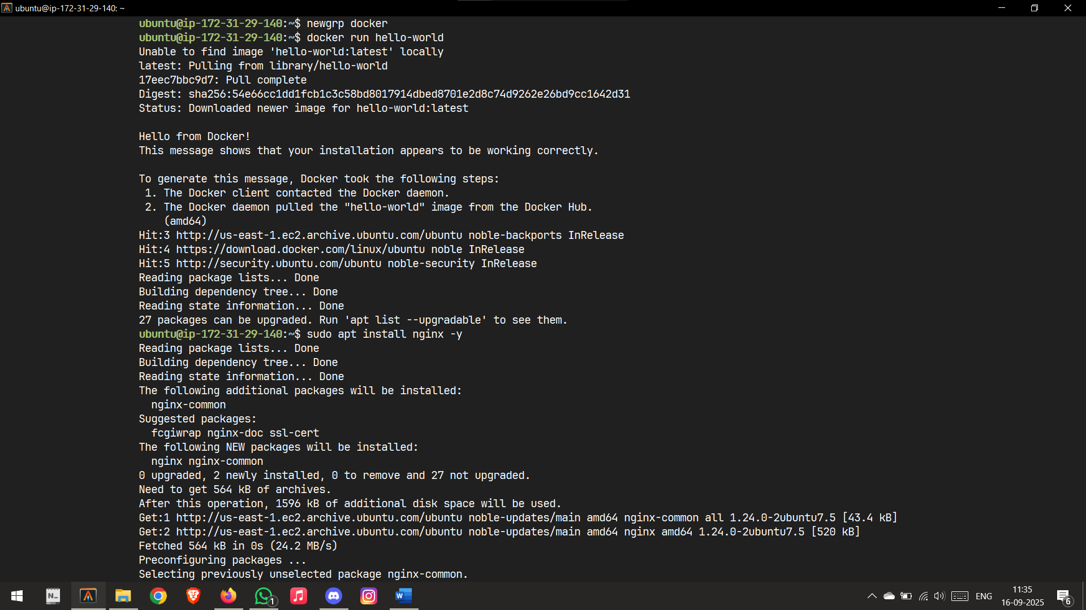

Installing nginx

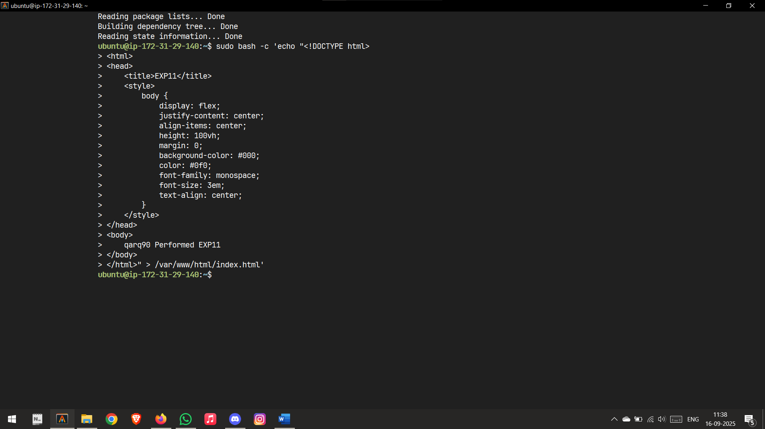

HTML file created

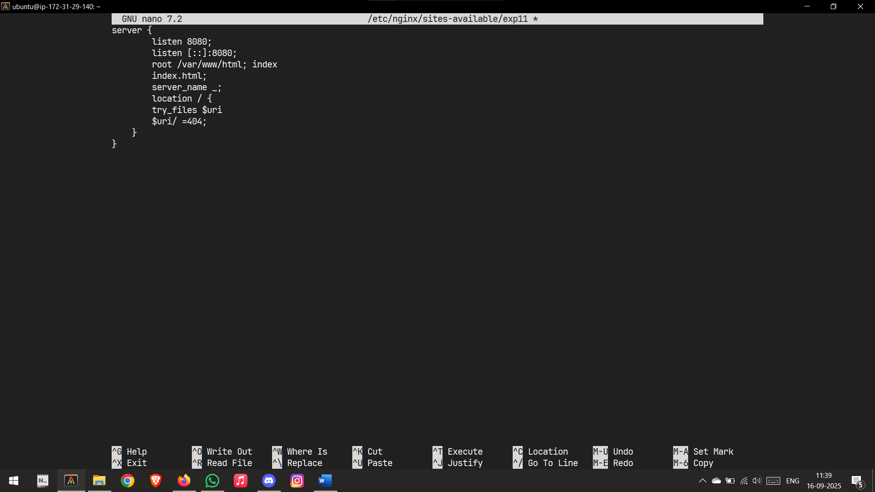

Config file to deploy

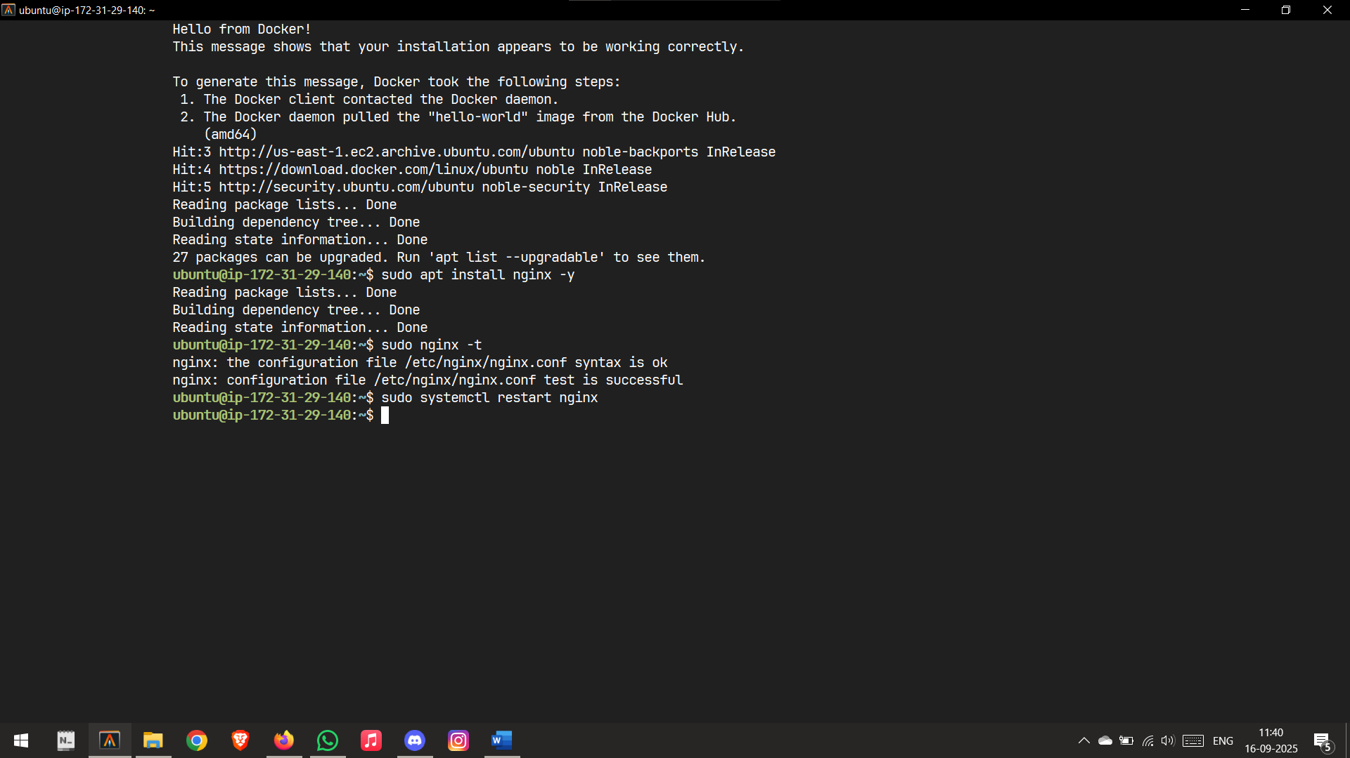

Nginx Launched

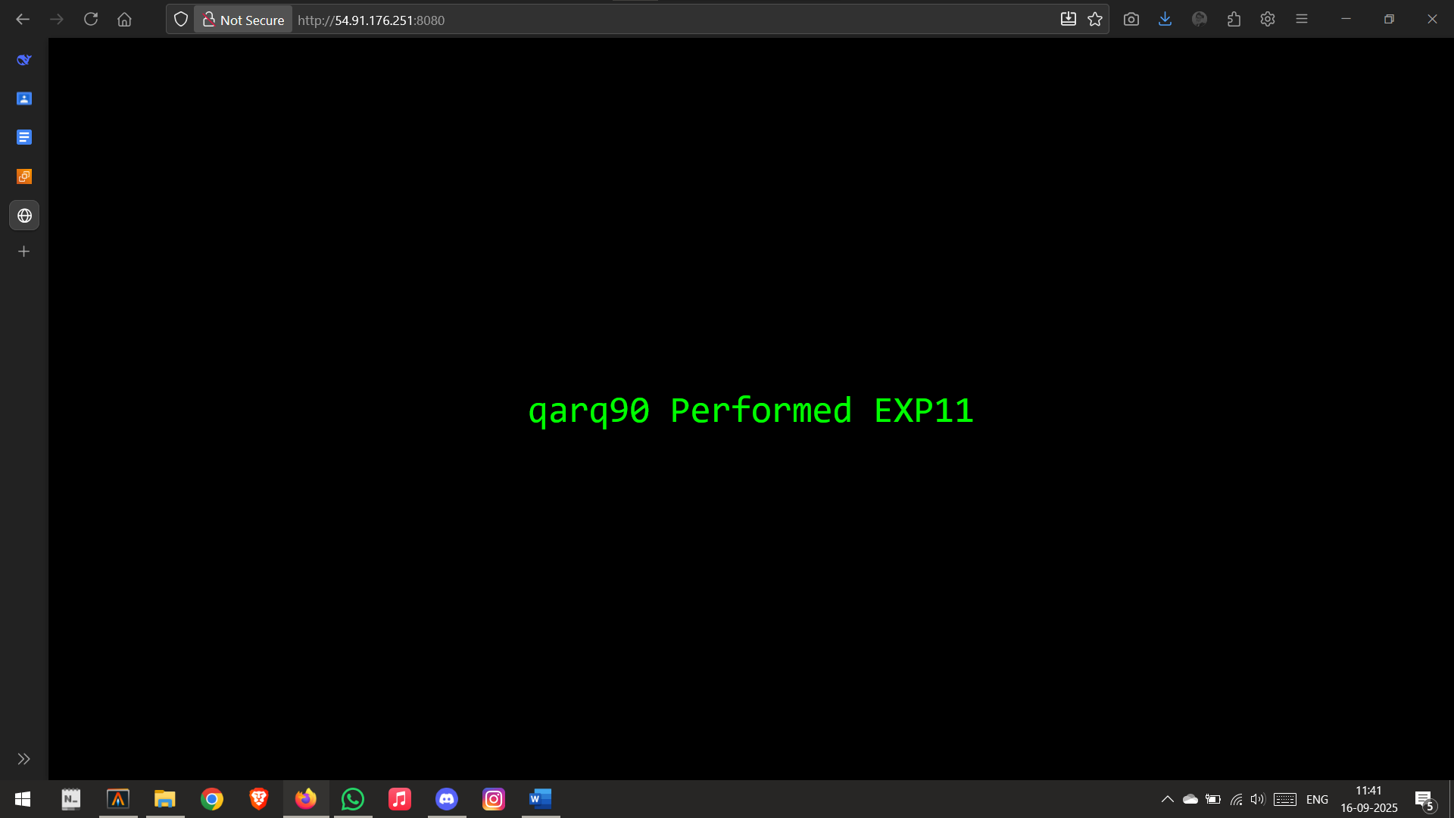

Deployed on 8080

**Commands to Deploy "qarq90 Performed EXP9" Webpage on EC2 Port 8080**

**1. Connect to EC2 Instance:**

bash

$ ssh -i "path/to/your-key.pem" ubuntu@your-ec2-public-ip

**2. Update System & Install NGINX:**

bash

$ sudo apt update

$ sudo apt install nginx -y

**3. Create the Custom HTML File:**

bash

$ sudo bash -c 'echo "<!DOCTYPE html>

<html>

<head>

<title>EXP9</title>

<style>

body {

display: flex;

justify-content: center;

align-items: center;

height: 100vh;

margin: 0;

background-color: #000;

color: #0f0;

font-family: monospace;

font-size: 3em;

text-align: center;

}

</style>

</head>

<body>

qarq90 Performed EXP9

</body>

</html>" > /var/www/html/index.html'

**4. Configure NGINX for Port 8080:**

bash

$ sudo nano /etc/nginx/sites-available/exp11

(Paste the following configuration into the nano editor, then save with Ctrl+X, Y, Enter)

nginx

server {

listen 8080;

listen [::]:8080;

root /var/www/html;

index index.html;

server_name _;

location / {

try_files $uri $uri/ =404;

}

}

**5. Enable the Site & Restart NGINX:**

bash

$ sudo ln -s /etc/nginx/sites-available/exp11 /etc/nginx/sites-enabled/

$ sudo nginx -t

$ sudo systemctl restart nginx

**6. AWS Security Group Configuration (To be done in the AWS Web Console):**

Go to **EC2 Console > Instances > Your Instance**

Click on the **Security Group** link in the **Security** tab.

Click **Edit inbound rules**.

**Add Rule** with:

**Type:** Custom TCP

**Port range:** 8080

**Source:** 0.0.0.0/0

Click **Save rules**.

**7. Access the Website:**

Open a web browser and navigate to:

text

http://YOUR_EC2_PUBLIC_IP:8080

or

text

http://YOUR_EC2_PUBLIC_DNS:8080